MID DEFENSE PREPARATIONS

1. INTRODUCTION: Should be almost Completed
2. BACKGROUND: Should be almost Completed
3. HISTORY: Should be almost Completed
4. LITERATURE REVIEW: Should be almost Completed
5. ANALYSIS: Should be more than 50%
6. COMPARISION: Should be more than 50%
7. TEST CASE & RESULTS: On Progress
8. DEMONSTRATION: Should be more than 50%
9. CONCLUSION: Should be towards it
10. ANNEX: Updated

Sample of Test Case and Results:

|  |  |
| --- | --- |
| Test Cases | Objective |
| 1 | To check whether the email and password match with the email and password saved in the database or not. |
| 2 | To check if the new password in the text field matches with confirm new password or not. |
| 3 | To check whether password changes or not after clicking Save button. |
| 4 | To check whether the photos are displayed if photos are inserted. |
| 5 | To check whether photo upload shows in both home page and photos page after uploading a photo. |
| 6 | To check whether updated status shows in both home page and user profile page. |
| 7 | To check if delete icon deletes specific picture or not. |
| 8 | To check whether featured option are functioning or not |
| 9 | To test whether result displays in search page after entering keywords. |
| 10 | To test whether the search results from search page redirect to Region or not |

INDIVIDUAL TEST CASE OF A SYSTEM

|  |  |
| --- | --- |
| Test Case | 1 |
| Objective | To check whether the email and password match with the email and password saved in the database of site users. |
| Test Data | Database email and password |
| Expected Test Result | System will grant access to the Admin account after match of email and password. |
| Actual Test Result | System grants access. |
| Conclusion | Successfully done. |

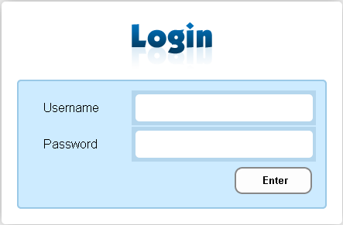 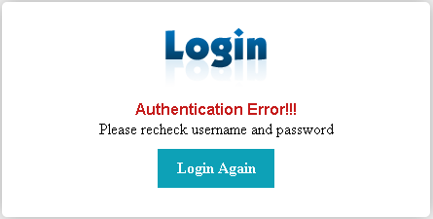

|  |  |
| --- | --- |
| Test Case | 2 |
| Objective | To check whether wrong password or Username is entered and Admin tries to log in |
| Test Data | Email and password |
| Expected Test Result | Message should appear |
| Actual Test Result | Message appears |
| Conclusion | Successfully done. |

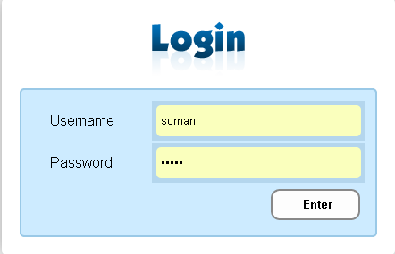 

|  |  |
| --- | --- |
| Test Case | 3 |
| Objective | To check whether error message displays when admin logout the page. |
| Test Data | Registration data |
| Expected Test Result | Success Report should appear |
| Actual Test Result | Message appears |
| Conclusion | Successfully done. |

 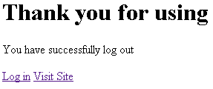

|  |  |
| --- | --- |
| Test Case | 4 |
| Objective | To check whether error message displays when the email is not in its format. |
| Test Data | email |
| Expected Test Result | Message should appear |
| Actual Test Result | Message appears |
| Conclusion | Successfully done. |

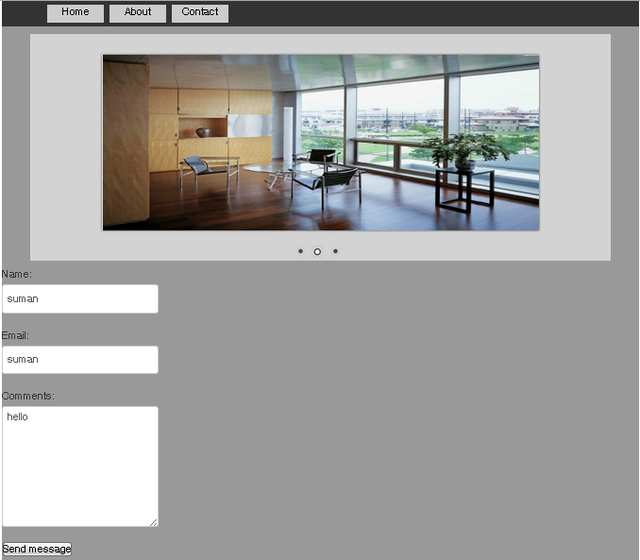

TEST CASE & RESULTS SAMPLE

1. TEST CASE 1

|  |  |  |
| --- | --- | --- |
| TEST CASE | EXPECTED RESULT | ACTUAL RESULT |
| TO TEST WHETHER THE LOGIN BUTTON WORKS OR NOT | BUTTON SHOULD WORK | BUTTON IS FUNCTIONAL |
| REMARKS | FUNCTIONAL | FUNCTIONAL |

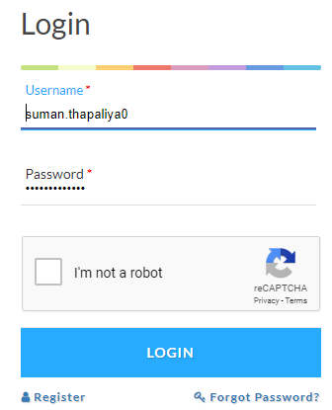

1. TEST CASE 2

|  |  |  |
| --- | --- | --- |
| TEST CASE | EXPECTED RESULT | ACTUAL RESULT |
| TO TEST WHETHER THE USERNAME & PASSWORD VALIDATED OR NOT | SHOULD BE VALIDATED | VALIDATED |
| REMARKS | FUNCTIONAL | FUNCTIONAL |

